A project report on
ARDUINO BASED ELECTRICAL SUBSTATION MONITORING SYSTEM
Submitted in the partial fulfillment of the requirements for the award of the degree of
BACHELOR OF TECHNOLOGY
IN
ELECTRICAL AND ELECTRONICS ENGINEERING
SUBMITTED BY
N.LOHITH KIRAN 18MH5A0210
S.NAGA VEERABABU 18MH5A0216
Y.RAMALAKSHMI 18MH5A0218
M.RATANCHAND 17MH1A0202
Under the esteemed guidance of
Mr.M.V. KUMAR REDDY, M. Tech
Assistance Professor

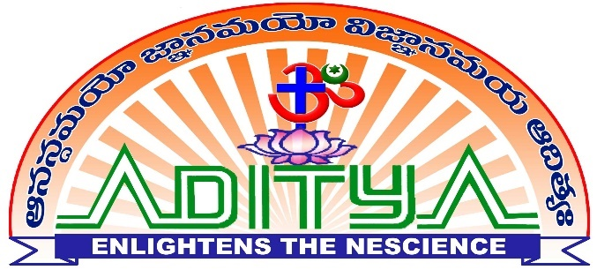
ADITYA COLLEGE OF ENGINEERING

Department of Electrical and Electronics Engineering

Approved by AICTE, Permanently Affiliated to JNTUK & Accredited by NAAC Recognized by UGC under Sections 2(f) and 12(B) of UGC Act, 1956 Aditya Nagar, ADB Road, Surampalem – 533 437.

2018-2021

CERTIFICATE
ADITYA COLLEGE OF ENGINEERING
Department of Electrical and Electronics Engineering
Approved by AICTE, Permanently Affiliated to JNTUK & Accredited by NAAC Recognized by UGC under Sections 2(f) and 12(B) of UGC Act, 1956 Aditya Nagar, ADBRoad,


Surampalem – 533 437.

This is certify that the project report entitled“ARDUINO BASED ELECTRICAL SUBSTATION MONITORING SYSTEM”being submitted by.
N.LOHITH KIRAN 18MH5A0210
S.NAGA VEERABABU 18MH5A0216
Y.RAMALAKSHMI 18MH5A0218
M.RATANCHAND 17MH1A0202

In the partial fulfillment of the requirement for the award of the degree of the Bachelor of Technology in Electrical and Electronics Engineering from Aditya college of engineering. It is the record of bonafied work, carried out by them at Aditya College of Engineering.

Project Guide Head of the Department
M.V. KUMAR REDDY, M.Tech K.MANOJ KUMARREDDY,M.Tech (Ph.D.)
Assistance Professor Associative Professor

ACKNOWLEDGEMENT
The satisfaction that accompanies successful completion of any task would be Incomplete without the mention of the people who made it possible and whose constant guidance and encouragement crown all the efforts with success. The acknowledgement transcends the reality of formality.
We thankful to my beloved guide cum project coordinator Mr. M.V. KUMAR REDDY , M.Tech , Assistant Professor who has spared his valuable time and append novel ideas to guide me in limelight. I am indebted to him without whom I may not have culminated to pinnacle of the project.
We also wish to convey my sincere thanks to Mr. K. M. K. REDDY, M.Tech(Ph.D), Head of the Department who provided vital information which was necessary of the project.
We thankful to Mr.A.RAMESH, M.Tech, Ph.D, Principal,Aditya College of Engineering for providing appropriate environmental required for this projects.
We also thankful to all staff members, lab technicians, librarians and friends who are directly and indirectly helped me in the completion of the project with flying colors.

With sincere regards

N.LOHITH KIRAN 18MH5A0210

S.NAGA VEERABABU 18MH5A0216

Y.RAMALAKSHMI 18MH5A0218

M.RATAN CHAND 17MH1A0202

DECLARATION

We hereby declare that this project titled as “ARDUINO BASED ELECTRICAL SUBSTATION MONITORING SYSTEM ” has been under taken at and this work is submitted to ADITYA COLLEGE OF ENGINEERING, Surampalem, affiliated to JAWAHARLAL NEHRU TECHNOLOGICAL UNIVERSITY, Kakinada in the partial fulfillment of the Degree of Master of Technology.

We further declare that this project work has not been submitted in full or part for the award of any other Degree in this or any other Educational institutions

N.LOHITH KIRAN 18MH5A0210

S.NAGA VEERABABU 18MH5A0216

Y.RAMALAKSHMI 18MH5A0218

M.RATAN CHAND 17MH1A0202

